**EEE361**

**ASSIGNMENT**

**SET-11**

1. If r = xax + yay + zaz  is the position vector of point (x, y, z), r = |R| and n is an integer, show that:

a. $∇∙ r^{n}R = (n + 3)r^{n}$

b. $∇× r^{n}R = 0$

c. $∇(ln r) = \frac{R}{r}$

d. $∇^{2}\left(lnr\right)={\left(\frac{1}{r}\right)}^{2}$

1. For a medium, µ = µ0 and ε = 5ε0. If H = 2cos ($ω$ t-3y)az A/m, Find the $ω$ and E.
2. The total electromagnetic energy is given below

W= $\frac{1}{2}\int{\left(E.D+H.B\right)dv}$

Show from Maxwell’s Equation that

$$\frac{∂W}{∂t} = - \oint{(E × H ∙ dS - \int_{V}{E∙ J dv}}$$

1. A wave is given is air:

E = (8ay – 6az) Sin $\left(ωt-4y-3z\right)$ V/m impinges a dielectric half- space as shown in Fig. Below. Find:

a. The incident angle $θ_{i}$

b. The reflected and Transmitted E and H field

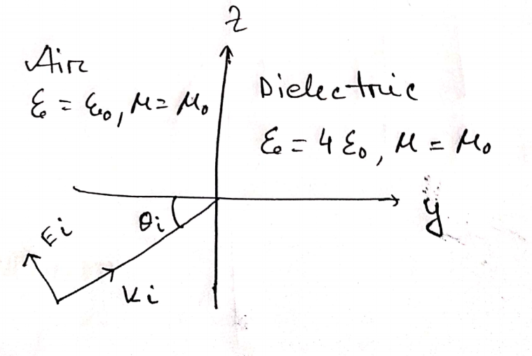

Fig: Problem 4

1. Suppose **E** fields and **H** fields are:

$$E = E_{0}e^{j\left(k.r-⍵t\right)}$$

$$H= H_{0}e^{j\left(k.r-⍵t\right)}$$

$Where$ k = kxax + kyay + kzaz and r = xax+yay+zaz

Show that $∇ × E = - ∂B/∂t$ can be expressed as K $×$ E = $μωH$ and deduce ak aE = aH

For the same fields:

Show that Maxwell’s equation in a source-free region can be written as

k.E = 0

k.h=0

k $×$ E = $μωH$

k $×$ H = $- μωH$

From these equations deduce ak aE = aH and ak aH = aE